LAB-2 TASK 1: PEAS SPECIFICATIONS
Delivery Robot and LLM-Based Student-Support Agent
Name: M.Ayyan Khan
Roll No: 042
Section: BSAI-3A

Introduction
PEAS stands for Performance measure, Environment, Actuators, and Sensors. It is used to describe the task environment of an intelligent agent by identifying how success is measured, where the agent operates, how it can act, and what information it can sense or receive.

1. Delivery Robot — PEAS Specification
PEAS Component | Concrete entries
P — Performance measure | 1. Deliver the correct parcel to the correct recipient and location. 2. Avoid collisions and keep pedestrians safe. 3. Deliver within the expected time. 4. Minimize unnecessary travel distance and battery consumption.
E — Environment | 1. Sidewalks, corridors, ramps, doors, lifts, and delivery locations. 2. Pedestrians, cyclists, pets, and vehicles. 3. Temporary obstacles, construction areas, and changing weather. 4. Parcels, drop-off points, and charging stations.
A — Actuators | 1. Drive motors and steering mechanism. 2. Brakes and speed controller. 3. Parcel compartment lock or robotic gripper. 4. Speaker, display, or delivery-notification interface.
S — Sensors | 1. Cameras and depth sensors/LiDAR to detect obstacles. 2. GPS, wheel encoders, and an inertial measurement unit (IMU) to estimate position and movement. 3. Proximity or bumper sensors for nearby obstacles. 4. Battery-level and parcel-compartment sensors.

Constraint / Performance Trade-off
The robot must balance delivery speed against safety. Moving faster may reduce delivery time, but it also increases stopping distance and the risk of colliding with people or obstacles. Therefore, safety should take priority over speed when the route is crowded or sensor information is uncertain.

Operational Assumptions — Delivery Robot
The robot operates in a mapped delivery area, has functioning sensors and actuators, and can access a route map and delivery instructions. GPS may be unreliable indoors, so wheel odometry and the IMU may also be used. The robot should stop or request assistance when it cannot safely determine a route or verify a delivery.

2. LLM-Based Student-Support Agent — PEAS Specification
PEAS Component | Concrete entries
P — Performance measure | 1. Give accurate answers grounded in approved course information. 2. Explain concepts clearly and at a level suitable for the student. 3. Respond promptly and respectfully. 4. Protect student privacy and escalate uncertain or high-impact questions instead of inventing answers.
E — Environment | 1. Student messages and the current conversation. 2. Approved syllabus, assignment instructions, course notes, and FAQ. 3. Course calendar and assignment-deadline information. 4. Instructor or student-support staff for escalation.
A — Actuators | 1. Generate written answers and explanations in chat. 2. Ask clarifying questions. 3. Provide links or references to approved course resources. 4. Draft an escalation message for a human instructor or support staff member.
S — Sensors / Inputs | 1. The student's current message and available conversation context. 2. Search/retrieval results from approved course files and FAQs. 3. Read-only course-calendar and assignment metadata returned by an authorized tool. 4. Student feedback or clarifications during the conversation.

Operational Assumptions and Tool Access — Student-Support Agent
The agent can access the current chat, approved course documents and FAQs through a retrieval/search tool, and read-only course calendar or assignment-deadline metadata. It may draft an email or escalation message, but the draft is not sent automatically. It cannot independently change grades, submit student work, access private student records, or sign in to external accounts unless explicitly authorized through an approved system. Questions involving grades, disciplinary matters, sensitive personal information, or unclear institutional policy should be referred to a human staff member.

Constraint / Performance Trade-off
There is a trade-off between speed and answer reliability. Responding immediately is convenient, but an answer based on incomplete context or outdated information may mislead the student. The agent should check approved sources, state uncertainty, or ask a clarifying question when needed, even if this takes more time.

Conclusion
PEAS makes the responsibilities and operating conditions of each agent explicit. The delivery robot prioritizes safe, reliable physical delivery, while the LLM-based student-support agent prioritizes accurate, helpful, privacy-aware guidance. Both systems must balance performance goals against practical constraints and handle uncertain situations responsibly.

LAB-2 TASK 2: ENVIRONMENT CLASSIFICATION
Delivery Robot and LLM-Based Student-Support Agent

1. Introduction and Assumptions
An environment is fully observable when the agent can obtain all relevant information needed to choose an action. It is partially observable when some relevant information is hidden, noisy, delayed, or unavailable. An environment is deterministic when a given state and action always lead to the same next state. It is stochastic when outcomes may vary because of randomness, uncertainty, or other agents' behavior.
The classifications below refer first to the real-world systems described in Task 1. For comparison, each system is also classified under a simplified simulator assumption. These labels depend on the sensors, tools, and simulator design; they are not universal properties of every possible robot or student-support system.

2. Delivery Robot

2.1 Real Environment
Observability: Partially observable.
Justification: The robot receives information from cameras, LiDAR/depth sensors, GPS, wheel encoders, and an IMU, but these sensors cannot reveal every relevant fact perfectly. Obstacles may be hidden behind corners or other people, GPS can be noisy, and the robot cannot directly know what a pedestrian intends to do.
Observable-variable example: the distance to a visible obstacle detected by LiDAR, or the robot's approximate position from GPS/odometry. Hidden-variable example: whether a pedestrian behind a parked vehicle is about to cross the robot's route.
Dynamics: Stochastic.
Justification: The same movement command may have different results because pedestrians move unpredictably, a surface may be slippery, weather may affect traction, or a sensor may be noisy.
Action-outcome example: a command to move forward for two metres may be completed on an empty, dry path, but slowed or stopped if a pedestrian enters the route. Thus the exact next state is not guaranteed even when the robot sends the same command.

2.2 Simplified Delivery-Robot Simulator
Assumption and classification: If the simulator exposes the exact position and velocity of every object, the robot's exact state, and all obstacles, it is fully observable to an agent that can access this complete simulator state. If the simulator uses fixed physics and scripted movements with no random noise, it is deterministic: the same state and action produce the same next state. For example, a forward action on a clear simulated path always moves the robot by the same distance.
Qualification: If the robot controller only receives simulated camera/LiDAR readings, some objects can still be hidden and its perception may be partial. If the simulator randomizes pedestrians, friction, or sensor noise, its dynamics are stochastic. Therefore, full observability and determinism apply only to the stated simplified simulator assumptions.

3. LLM-Based Student-Support Agent

3.1 Real Environment
Observability: Partially observable.
Justification: The agent can read the student's messages and approved course materials, and may query read-only course-calendar or assignment metadata. However, it cannot directly observe the student's actual understanding, unstated circumstances, or all possible changes to course policy. It also cannot assume that a student has shared all relevant information.
Observable-variable example: the text of the student's question, the syllabus content retrieved by the approved search tool, or a deadline returned by the course calendar tool. Hidden-variable example: the student's actual level of understanding or an unmentioned personal difficulty that affects the question.
Dynamics: Stochastic (under the stated LLM assumption).
Justification: Assume the agent uses a generative LLM whose output can vary, and that student responses and interpretations are not fully predictable. The same question may receive different wording or, occasionally, a different answer. A student may also interpret the same explanation differently.
Action-outcome example: the agent gives an explanation of a programming concept. One student may understand and solve the task, while another may remain confused and ask a follow-up question. The agent cannot guarantee the learning outcome. The text output itself may also vary if generation sampling is enabled.

3.2 Simplified Student-Support Simulator
Assumption and classification: A test simulator can be fully observable if every input is provided as structured data—for example, the exact student query, relevant course facts, intended student-knowledge state, and expected response label. It can be deterministic if it uses fixed rules or a fixed response table, so the same input always produces the same output. Example: a rule that maps a question about the deadline to a fixed date from a test record returns the same date each time.
Qualification: If the simulator does not expose the simulated student's knowledge state, it is partially observable from the agent's perspective. If it calls a generative LLM with sampling enabled, uses randomized student responses, or includes noisy retrieval, outcomes may remain stochastic. A fixed model configuration without sampling may be more repeatable, but it should not automatically be assumed perfectly deterministic across different hardware or software versions.

4. Summary Table
System / setting | Observability | Dynamics | Reason in brief
Delivery robot — real world | Partially observable | Stochastic | Sensors miss or distort some information; people and physical conditions vary.
Delivery robot — simplified simulator | Fully observable if complete state is exposed | Deterministic if no randomness | Simulator can reveal all state and use fixed transitions.
Student-support agent — real world | Partially observable | Stochastic under generative-LLM assumption | Student understanding/context is hidden; responses and learning outcomes can vary.
Student-support agent — simplified simulator | Fully observable if all relevant variables are supplied | Deterministic if fixed rules/output table is used | Structured inputs and fixed outputs make the test repeatable.

5. Conclusion
Under realistic assumptions, both the delivery robot and the LLM-based student-support agent operate in partially observable and stochastic environments. Their sensors and tools provide useful but incomplete information, and outcomes can vary. A simplified simulator may be fully observable and deterministic when it exposes every relevant state variable and removes randomness. The classification must therefore state the assumptions instead of treating the labels as absolute.

Lab 2 — Task 3
Stateful HVAC Controller

Objective
Extend the HVAC controller so it remembers its previous target mode and does not send an identical control command repeatedly. The controller returns the target mode and whether a command should be sent.

Control Logic
Occupancy priority is checked first. If the room is empty, the target mode is OFF regardless of temperature. If the room is occupied, temperature below 18°C selects HEAT, temperature above 26°C selects COOL, and temperatures from 18°C through 26°C select OFF. Thus, both exact boundaries (18°C and 26°C) select OFF.
The controller starts with previous_mode = OFF. It sends a command only when target_mode differs from previous_mode. After each percept, it stores the target as the previous mode for the next step.

Python Implementation
The complete executable implementation is included in lab2_model.py. The core method is:
previous = self.previous_mode
target = self.target_mode(temperature, occupied)
should_send = target != previous
self.previous_mode = target
return target, should_send, previous

Execution Trace
Test case | Previous mode | Percept | Target | Outcome
Repeated cold percept 1 | OFF | 17°C, occupied=True | HEAT | SEND COMMAND
Repeated cold percept 2 | HEAT | 17°C, occupied=True | HEAT | NO COMMAND
Lower exact boundary | HEAT | 18°C, occupied=True | OFF | SEND COMMAND
Upper exact boundary | OFF | 26°C, occupied=True | OFF | NO COMMAND
Mode transition | OFF | 27°C, occupied=True | COOL | SEND COMMAND
Empty room | COOL | 30°C, occupied=False | OFF | SEND COMMAND

How to Run and Verify
Run `python lab2_percepts.py` to display the trace. Run `python lab2_check.py` to execute the assertions. The test script passes all required cases.

Conclusion
The controller remembers its previous target and suppresses duplicate commands. It correctly handles repeated percepts, both exact temperature boundaries, a HEAT/OFF/COOL transition, and an empty room where occupancy priority forces OFF.

Code Screenshot:
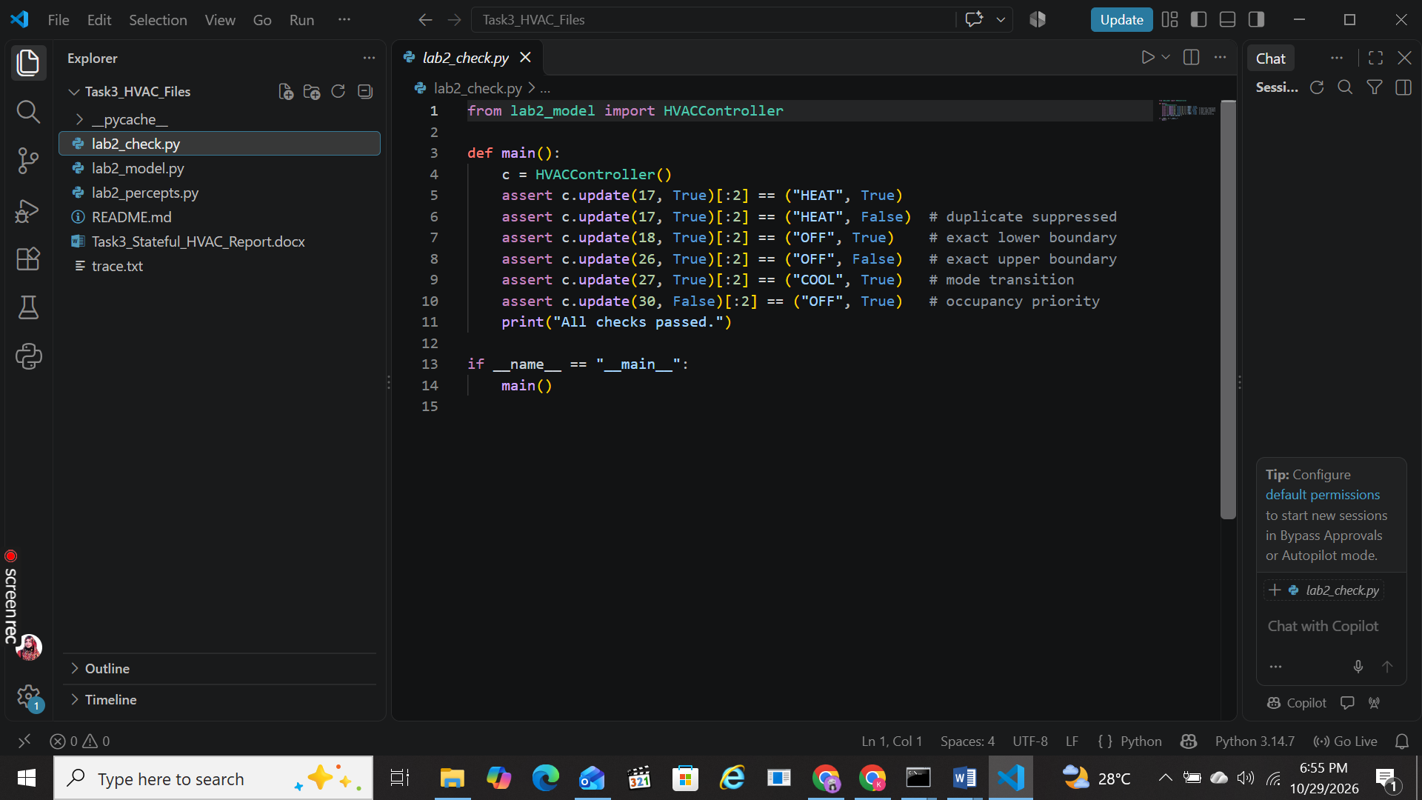
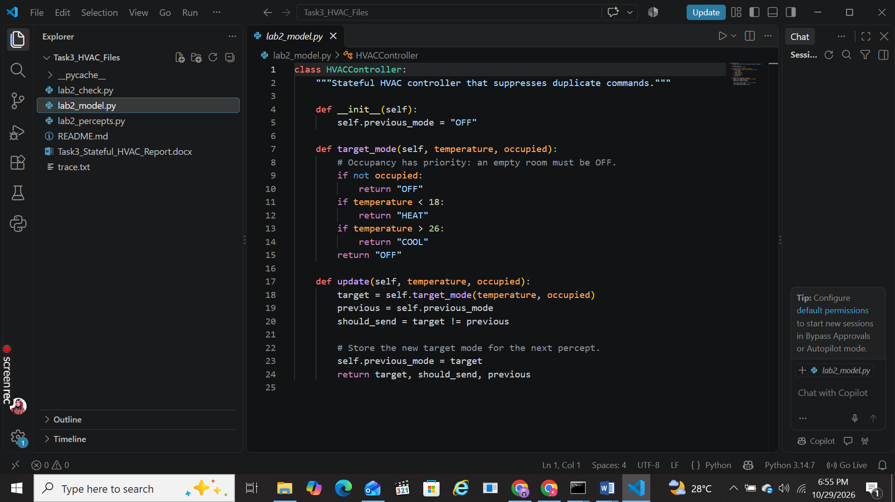
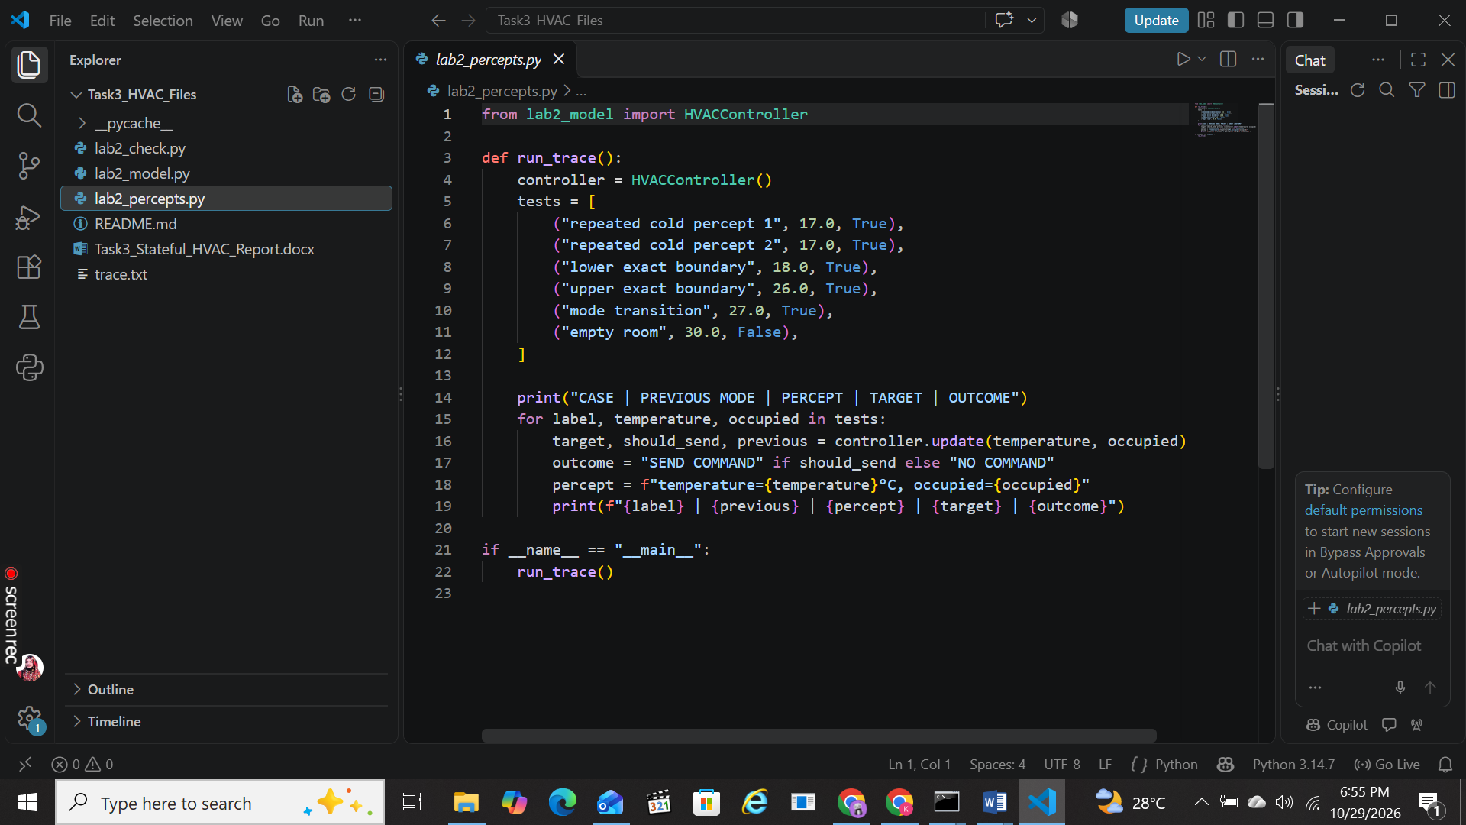

OUTPUT:
